Social work is a profession that helps enhance the well-being of individuals, families, groups and communities. Social Work Virtual Pal Finder is a mobile app (Android/iOS) designed to support the connectivity of social workers across the globe and to connect and interact with other social workers. The goal is to create a simple app with functionality that encourages and supports connectivity and collaboration that will have enough functionalities that would help to meet all the interests of social workers while helping them expand their network and share their work and ideas globally.

**User Guide with Steps and Screenshots**

The Social Work virtual Pal Finder is intended to be a global product connecting social workers with various goals, ideas and interests across the world. This is a hybrid mobile app for Android/iOS which will be on English language. The app will not support push notification. The idea for Social Work Virtual Pal Finder was conceived as the members of the profession wanted to use an app that would give all the social workers across the globe a platform to express their work and connect among different categories of social work. People working on any kind of social work with a wish to connect, expand, interact and collaborate with people of the same interest can use this app. When the app is up and running, the user will be able to login to it, create a profile, search for workers with certain keywords and basically connect with one another on a single platform.

The app is primarily intended for social workers and aims to provide them with a platform to connect and interact with each other and to build their network. This application is very user-friendly and will not need any high-level technical background to use it. Social workers with a valid email address and password can log in to the app.

This User guide displays all the features and functions that the application contains. It has a step by step procedure on how to use the application.

**Screenshots and steps to use the application**

1. **Registration**

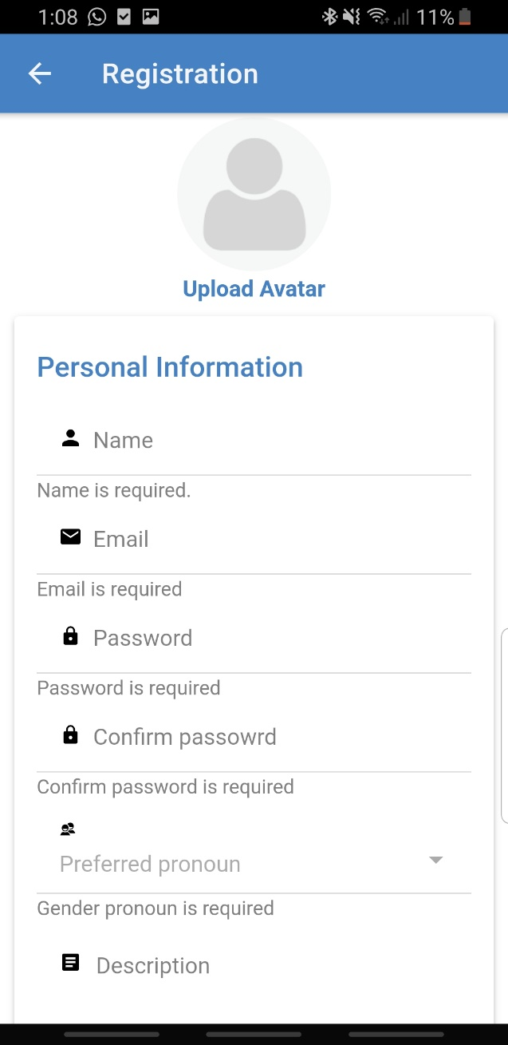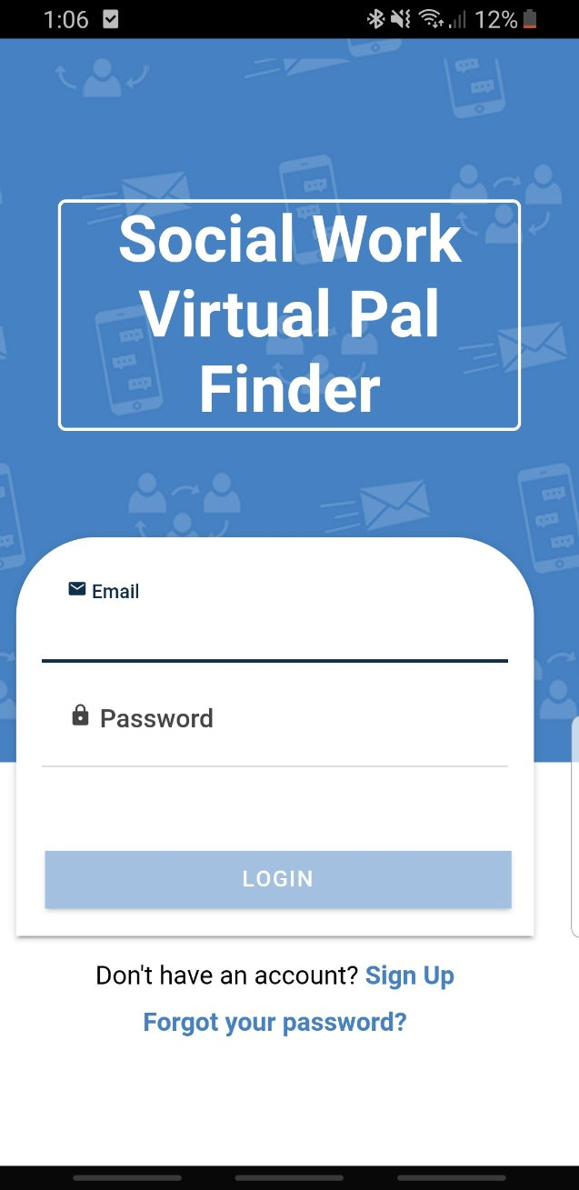

Register to the application by clicking on **Sign Up** button. Registration page is displayed on click of Sign Up button. The Registration page looks as shown in the screenshots.

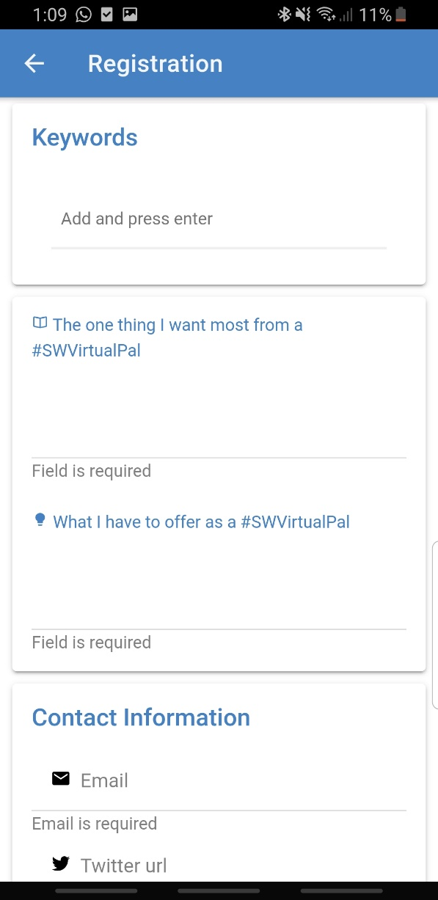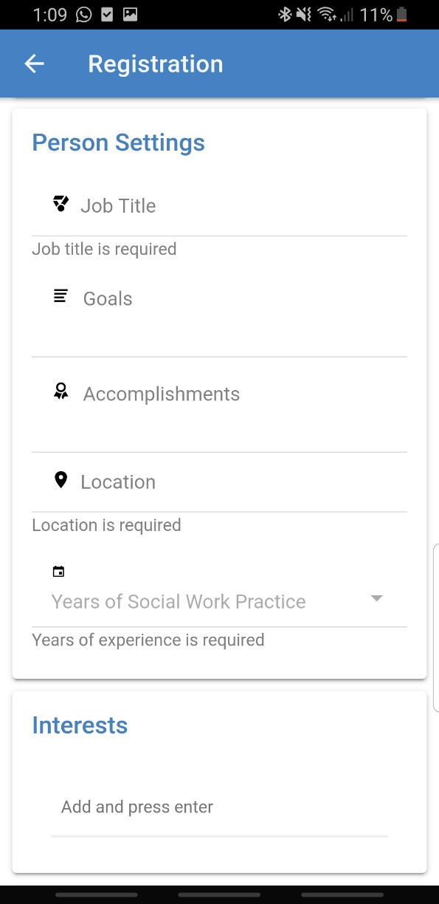

Enter the details in the registration page. The registration page is very important as the user will be later scrutonized by the administrator based on the information specified by the user in the registration page. Please provide valid information for the administrator to accept the profile.

The next page has a few screenshots demonstrating the registration page.

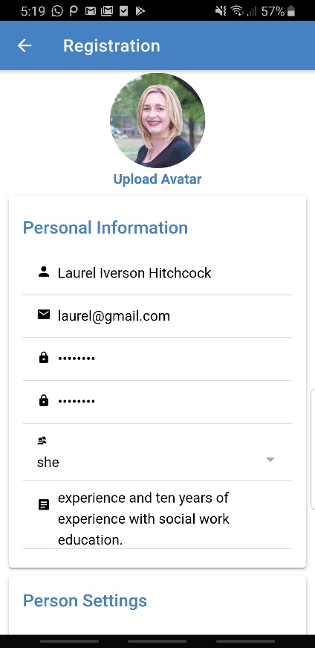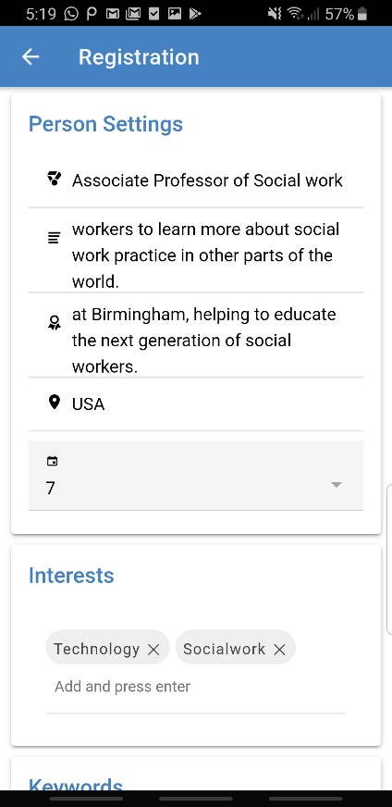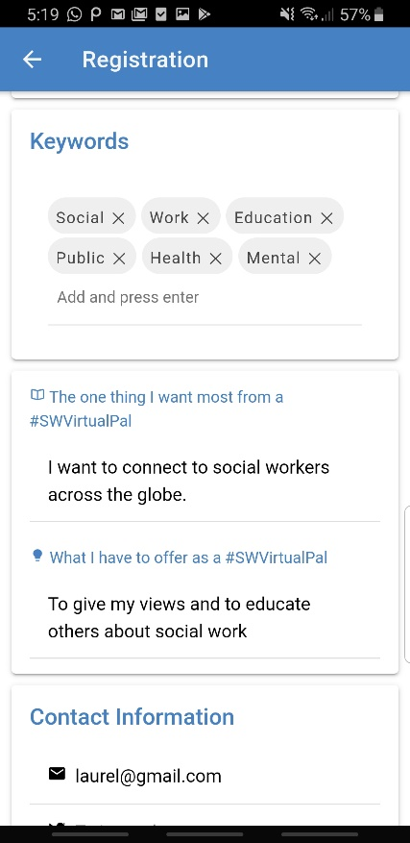

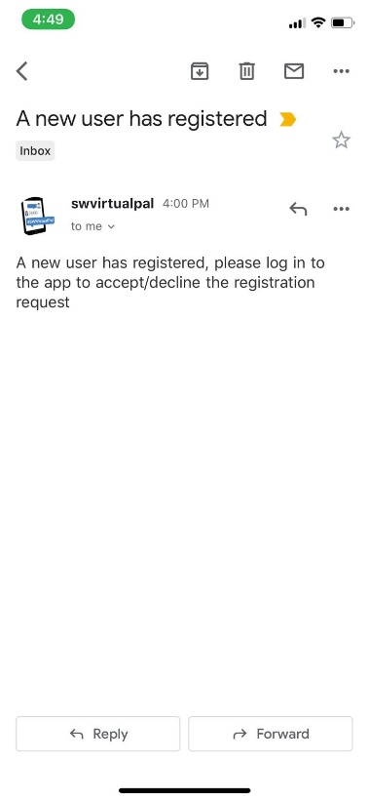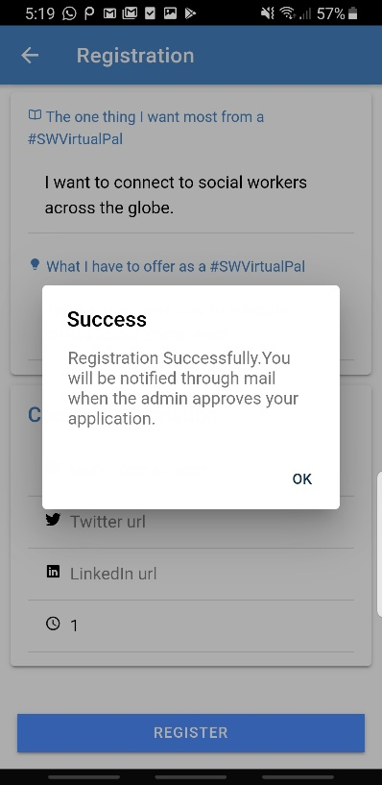

Enter valid details while filling the registration page. Please provide a valid email id and give a strong password. Fill in all the required fields. Do not use special characters while giving interests and keywords.

After registration your profile will be sent to the administrator for review and the administrator can either accept or reject your profile. The admin will also get a mail notification to a customisable email id saying a **new user has registered.**

1. **Admin Web Application**

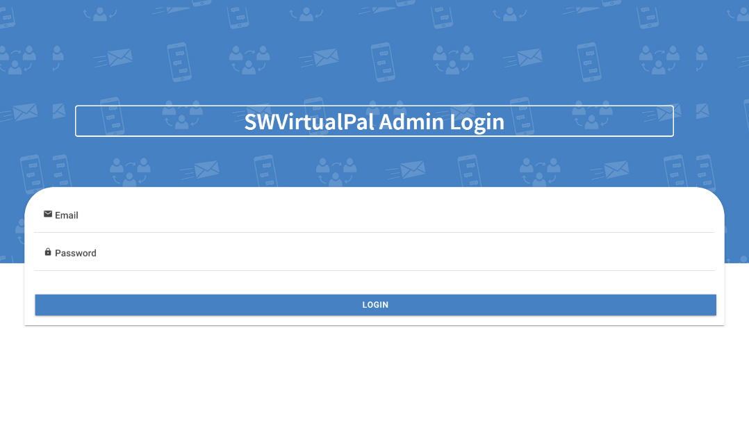

To login to the admin web application use this URL: **https://swvp-server.herokuapp.com/**

Log into the admin web application with the email: **admin@123** and password **admin1**

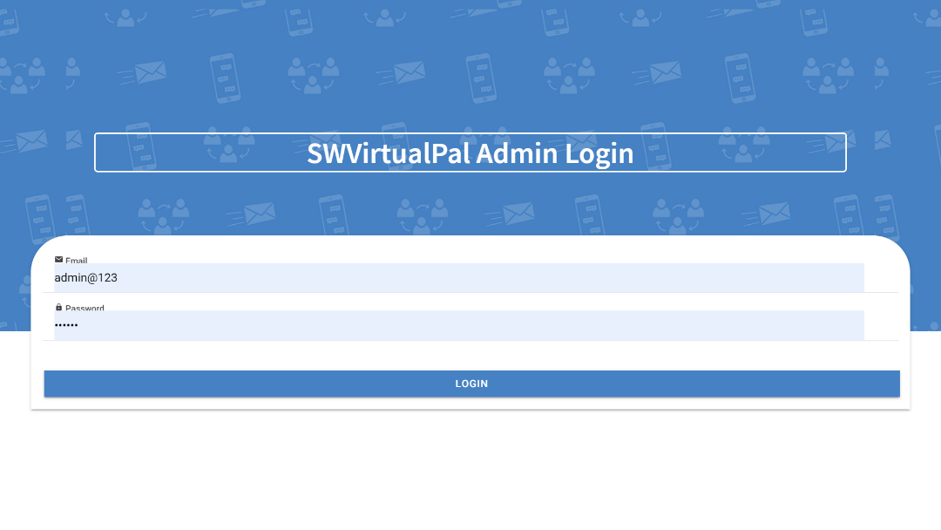

The admin web application has 3 tabs **User Requests**, **Set Public fields** and **Ban User**.

**User Requests**

1. When any user registers to the mobile application the admin gets the entire detail of the user and can view the details by clicking on the profile request.
2. The admin can either accept or reject the user registration on the basis of the information provided by the user.
3. On click of **Accept** button the user will be able to login to the mobile application with his credentials.
4. On click of **Decline** button the user will not be able to login to the mobile application.

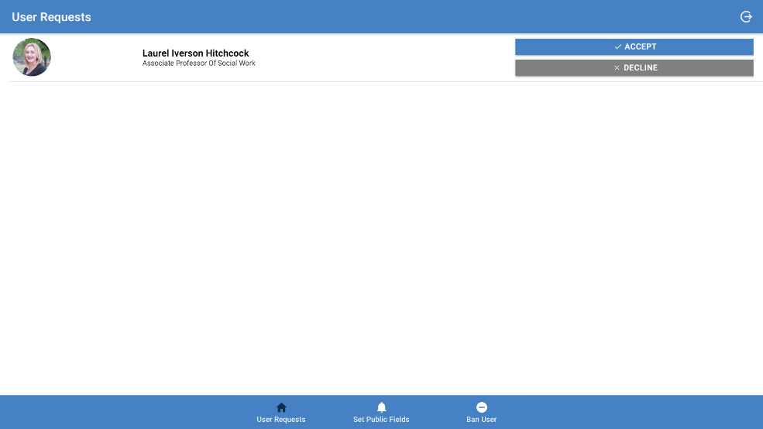

**Set Public fields**

1. Admin can control which profile details can be visible in the user profile.
2. 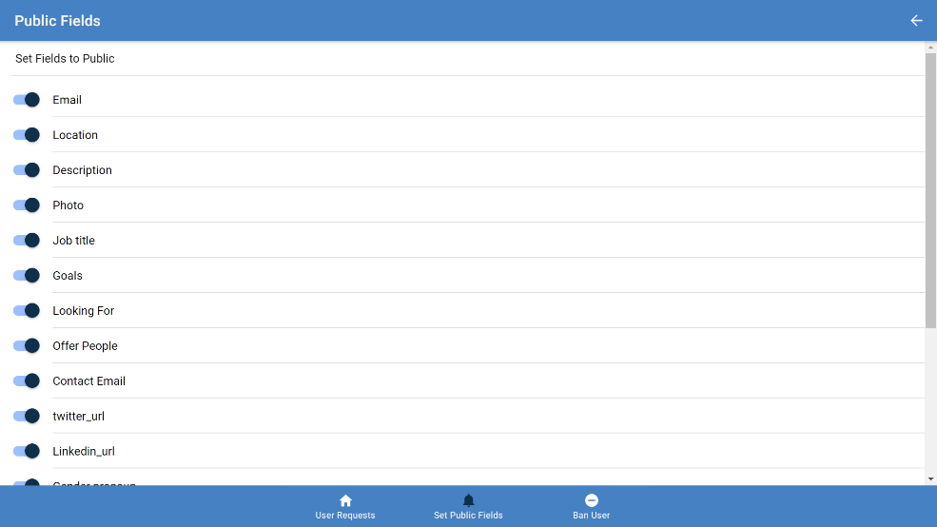Click on the toggle buttons to set the fields on/off.

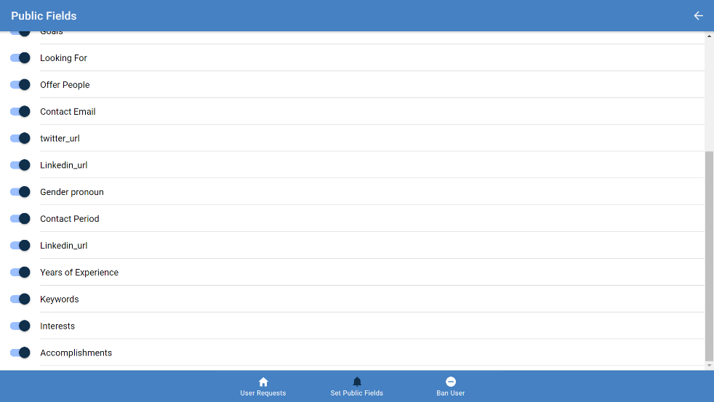

**Ban User**

1. The Admin can Ban the user who is behaving inappropriately and who does not adhere to the rules of the application.
2. On click of the Ban button the admin would be asked to confirm the choice and when the user is banned the user will not be able to use the application nor register with the same email id.

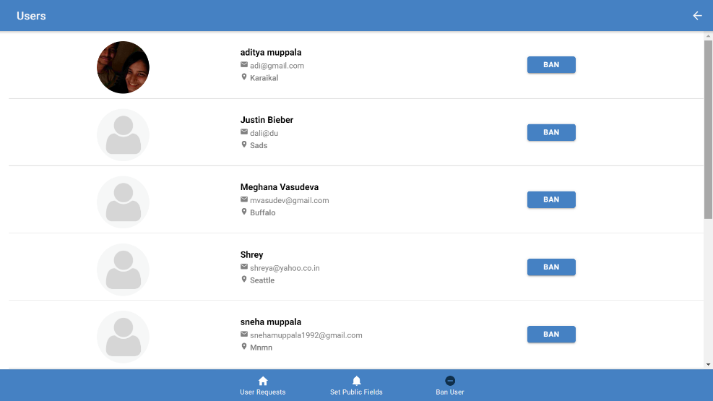

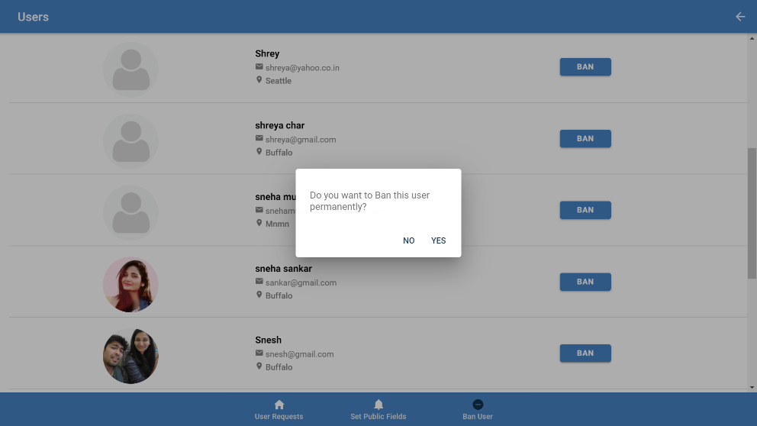

1. **User Login and application features**

The mobile application has 3 tabs **Connections**, **Home** and **Notifications** and on the header there is a **Search bar** and a **Settings** button.

**Connections:**

1. The connections tab shows the friend requests and suggested friends. It also has view all connections button which will display all the friends of the user.
2. User can accept/decline a connection request. On click of accept button the user who sent a connection request is a friend and you could see that profile by clicking view my connections button.
3. The suggestions show user profiles of users with similar interests and has a connect button. When the profile is clicked on the user profile is displayed.
4. Visit the user profile. The profile will have a send connection request which will send a connection request to that user.

**Notifications:**

1. 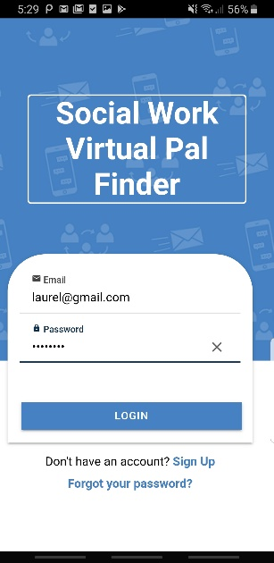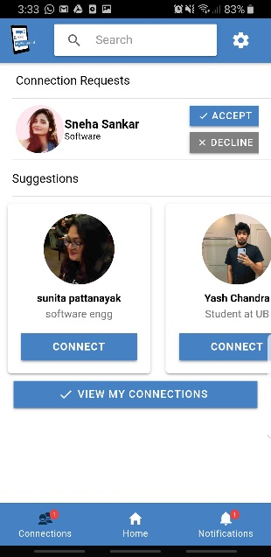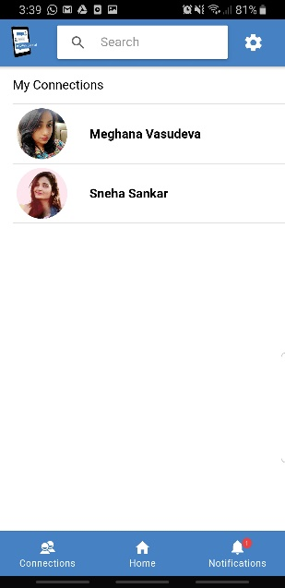When that user accepts your friend request you will receive a notification saying “*Username* has accepted your invitation”.

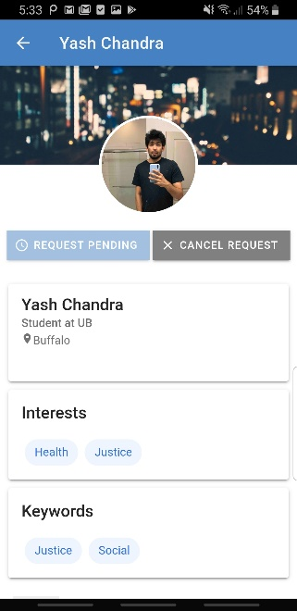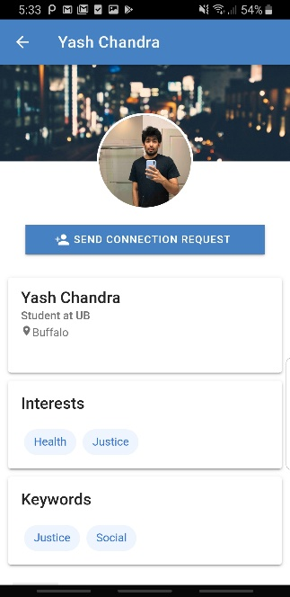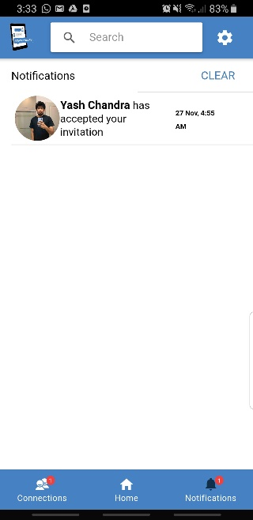

**Home:**

1. The Home tab will display all the user details including number of connections.
2. The small pencil icon at the right top corner is the edit button. On click of the edit button the user will be navigated to an edit page where the user can edit all the details.
3. The profile photo can be edited by clicking on the profile picture and choosing the image from gallery or clicking a photo with camera.

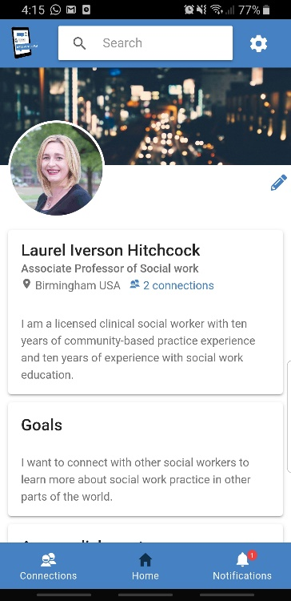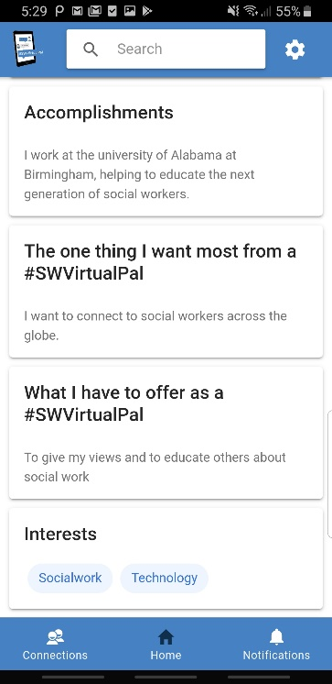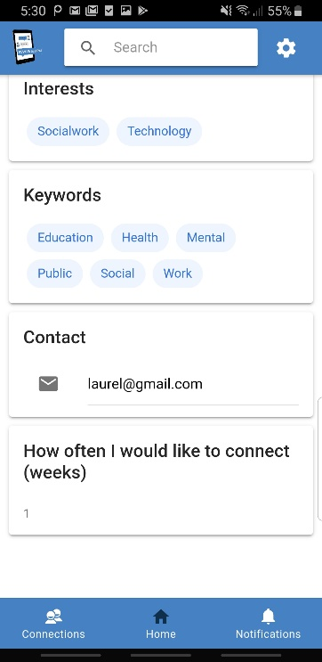

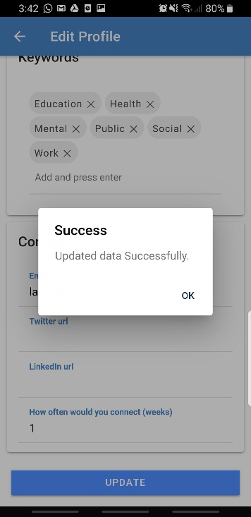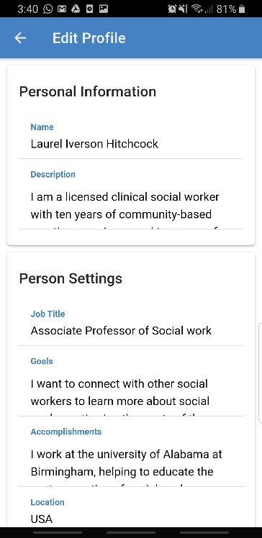

**Search:**

1. The search bar is used to seach a user based on name, location, interest and keywords.
2. Type the information to be searched on the search bar and hit enter.On hit of enter button the user is navigated to search page where the user details with respect to search is displayed.
3. Below is an example where I have searched the name “Sneha”, location “Buffalo” and keyword “Social” and the users with the specific search keywords have been displayed below.

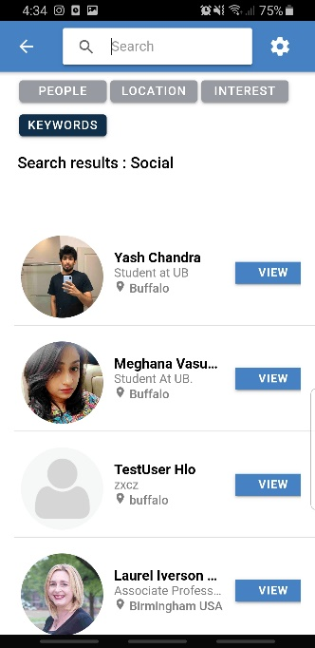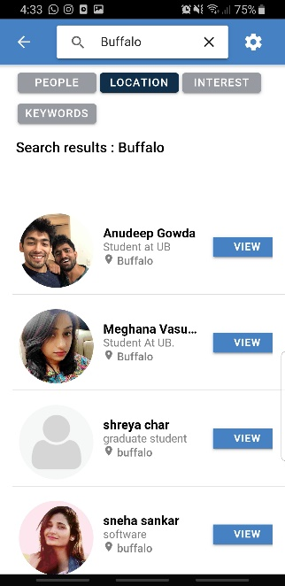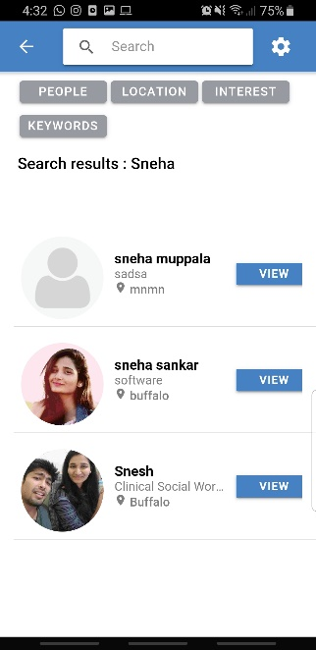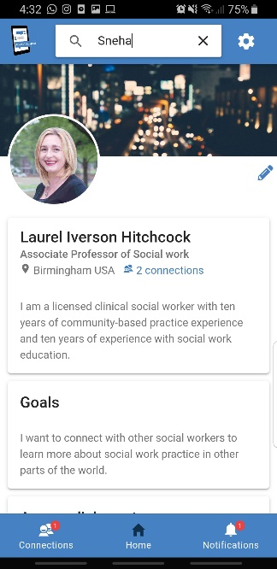cc

**Settings:**

1. The settings button is located on the top right corner. On click of the settings button the user is navigated to the settings page where there are 4 fields which perform the following functionalities **Remove Profile,** **Change Password** ¸ **About App** and **Log out**.

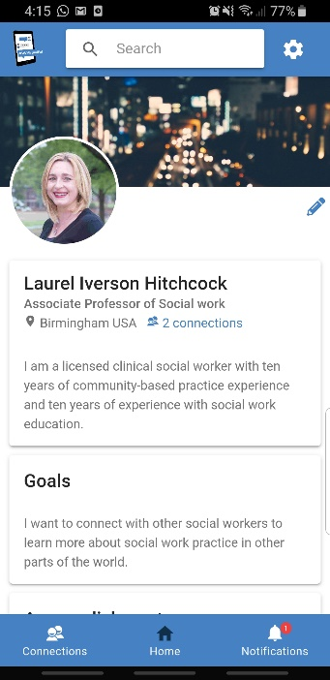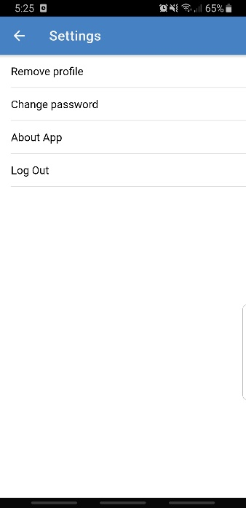

1. **Remove Profile**

On click of Remove Profile field the user will get a pop up asking “Are you sure you want to remove your profile” and the user is asked to enter the password and on click confirm the profile is deleted and the user will no longer be able to login to the application with the email and password.

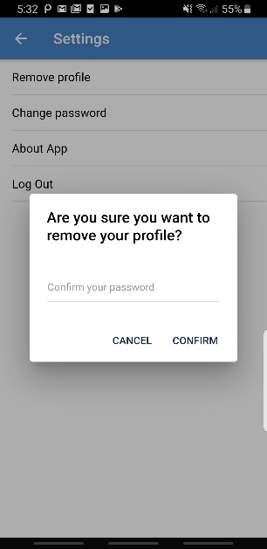

1. **Change Password**

On click of change password the user is navigated to change password page where the user is asked to enter the current password and new password. On click of change password button a success message is displayed saying “Password has been successfully reset.”

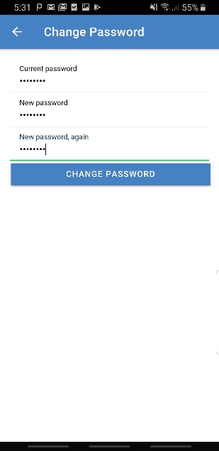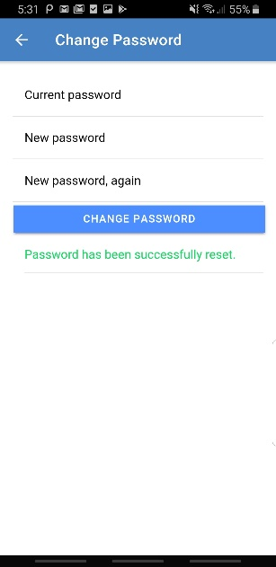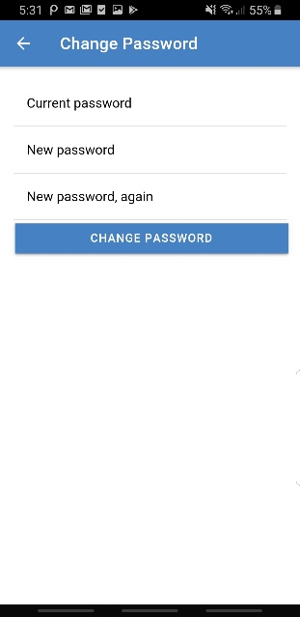

1. **About App**

On click of About app field the user is navigated to About App page where the app description is present with a few links related to the application. When clicked on these links the user is navigated to the respective websites.

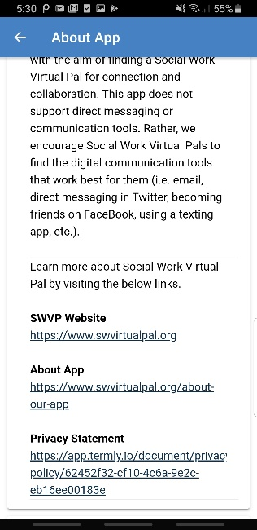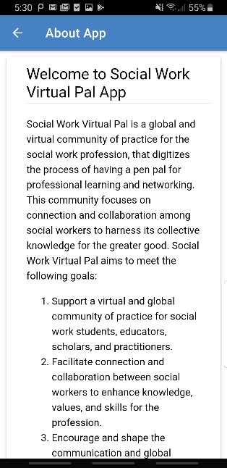

1. **Log out**

When the user clicks on the log out field the user is logged out of the application and can log in to the application again by entering the email and password.